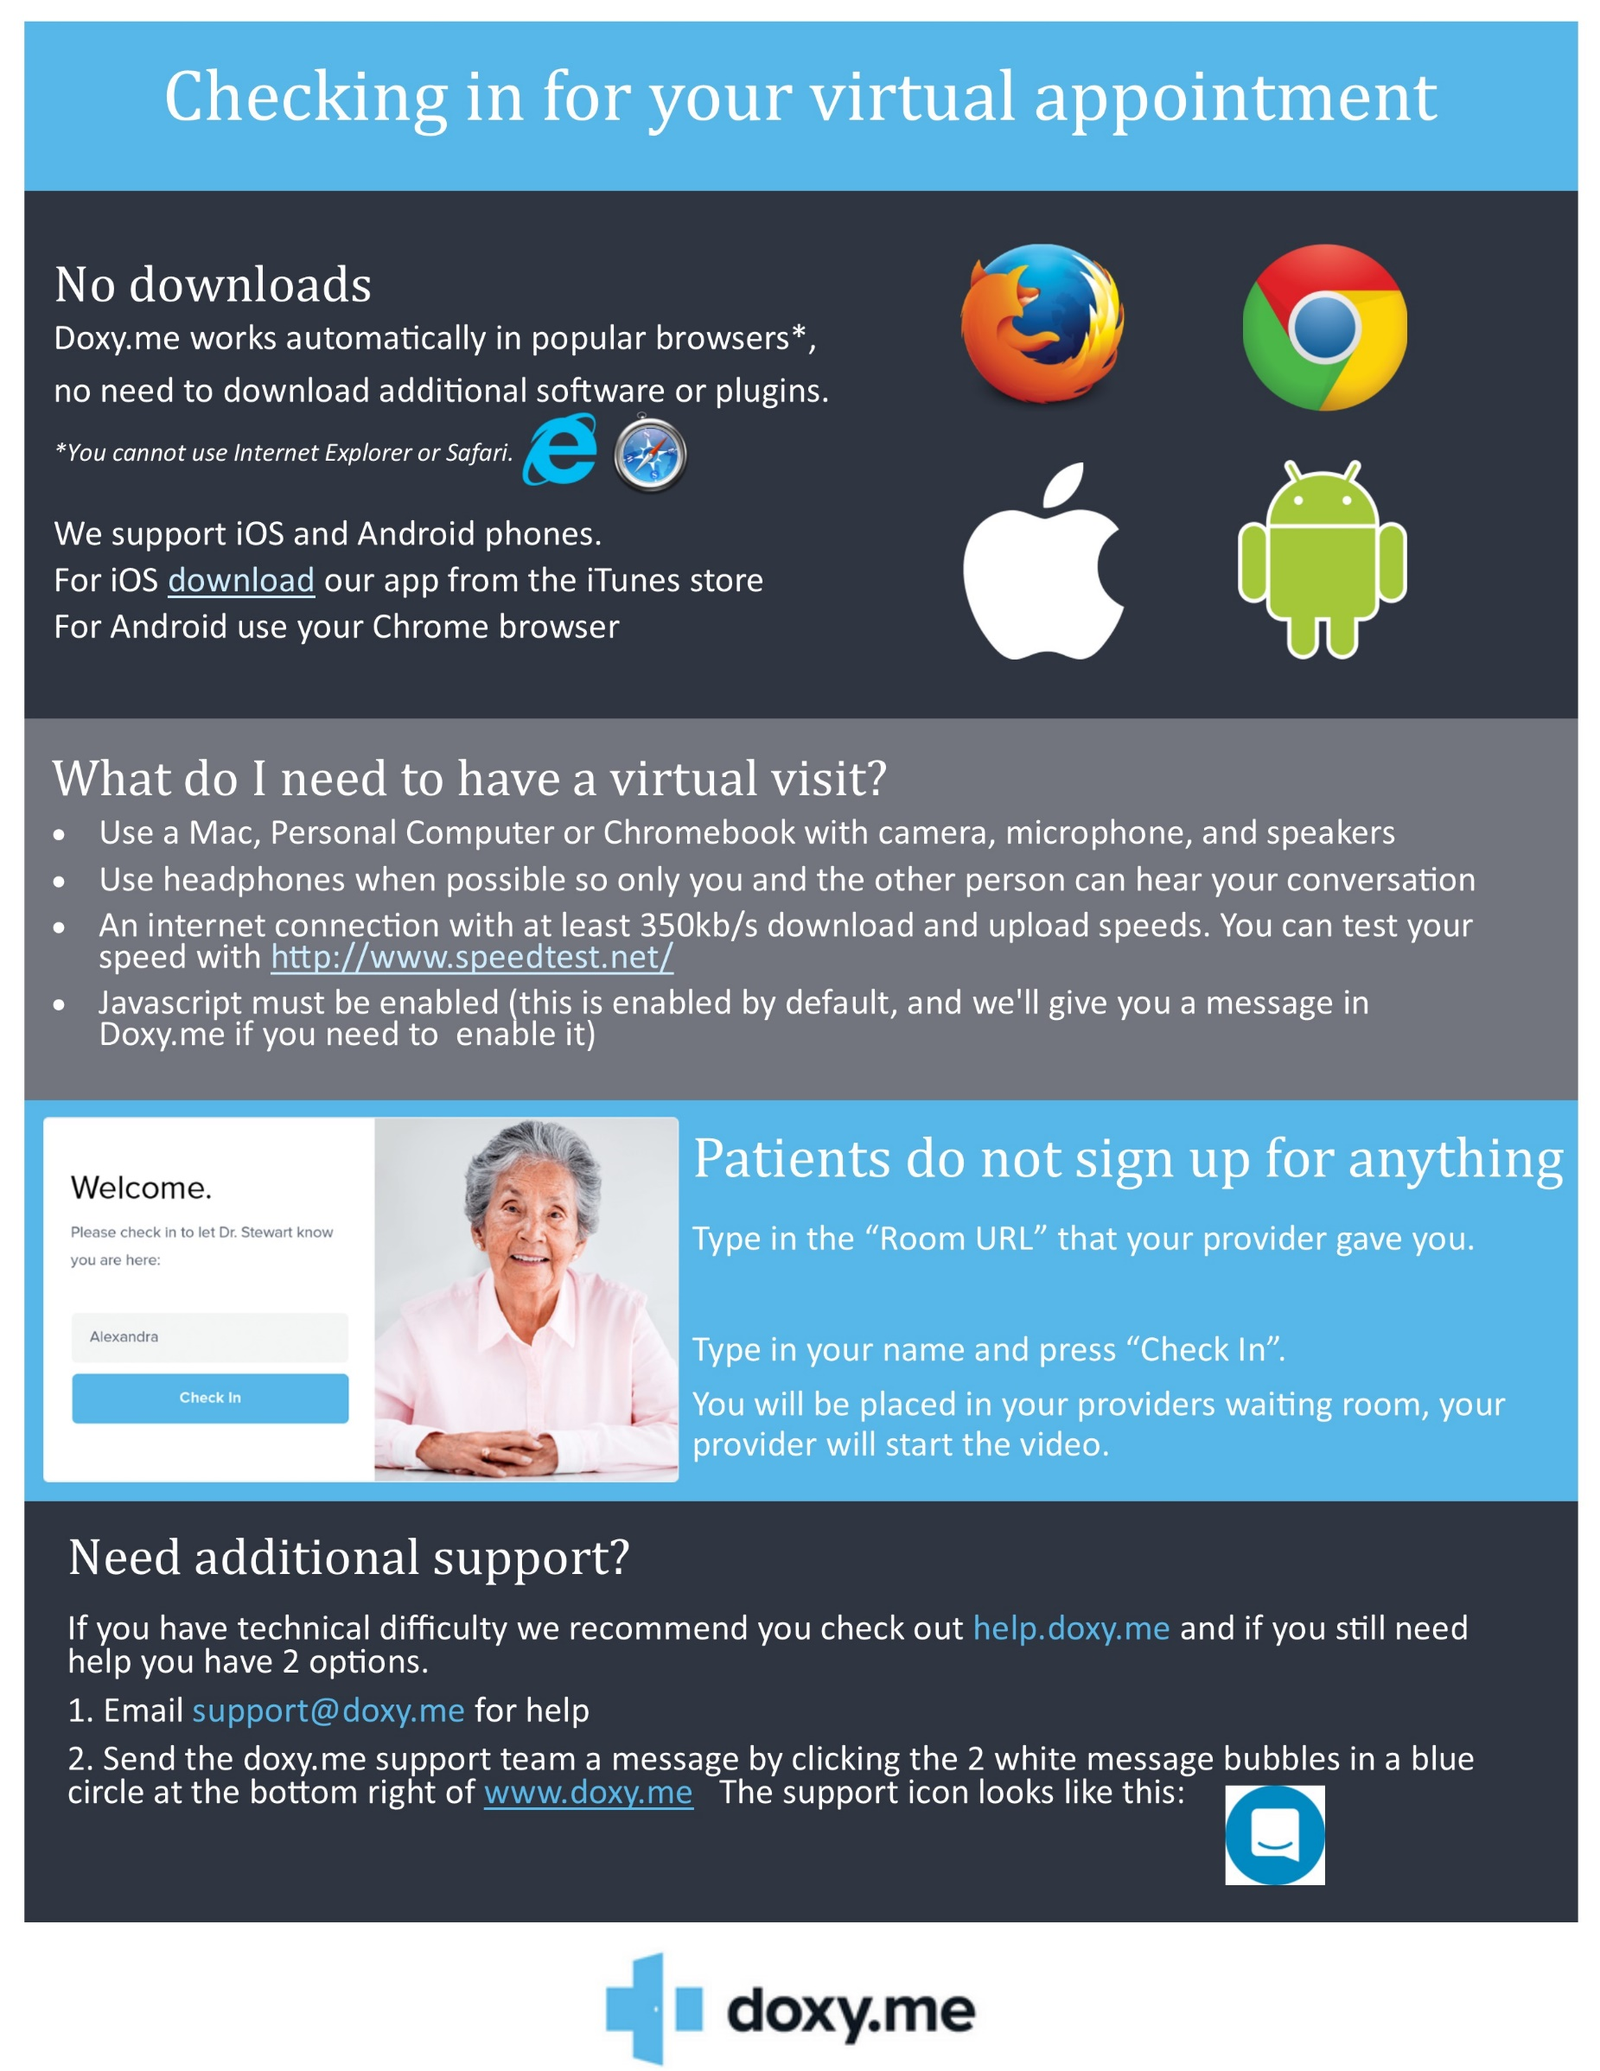

Will look like www.doxy.me/DrGadFriedman